Architecture Solution Design

[BiggyAI Solution Design]

[RITM1295263 | ACBSD-4524]

Version Control
Version Control |  |  |  |  | Approvals
Version | Date | Author/  Updated By: | Status | Comment | Pre-ARB | GTS ARB | Global ARB | GITB
01.00.00 | 2025-12-23 | Mohamed Kerbachi | Initial Document |  | ☐ | ☐ | ☐ | ☐
 |  |  | Choose an item. |  | ☐ | ☐ | ☐ | ☐
 |  |  | Choose an item. |  | ☐ | ☐ | ☐ | ☐
 |  |  | Choose an item. |  | ☐ | ☐ | ☐ | ☐
 |  |  | Choose an item. |  | ☐ | ☐ | ☐ | ☐
 |  |  | Choose an item. |  | ☐ | ☐ | ☐ | ☐
 |  |  | Choose an item. |  | ☐ | ☐ | ☐ | ☐

Table of Contents
Version Control 2
Table of Contents 3
1. Distribution and Contacts 6
2. Artifacts 7
3. Summary 8
3.1 Background 8
3.2 Solution Description 8
3.3 Business Unit(s) Impacted 8
4. Requirements 9
4.1 Use Cases 9
4.1.1 Use Case Requirements 9
4.1.2 Business Requirements 9
4.2 Functional Requirements 9
4.3 Non-Functional Requirements 10
Observability, Logging and Monitoring Requirements 10
Fault Tolerance & Resiliency Requirements 10
Availability Objectives 10
Performance Requirements 10
Capacity Requirements 10
4.4 Security Requirements 11
Security Requirement 11
4.5 Data Requirements 11
Data Requirement 11
4.6 Capability Map 11
5. Architecture 12
5.1 Alignment to Principles 12
5.2 Baseline Architecture 13
5.3 Target Architecture 14
5.3.1 Overview 14
5.3.2 Technology Components & Architecture Impacts 14
5.3.3 Gap Analysis 15
6. Components 16
6.1 Components or Patterns Used 16
6.1.1 Component Architecture Diagram 17
6.1.2 Components or Pattern Table 17
6.2 Integration Architecture 18
6.2.1 Integration Architecture Diagram 18
6.2.2 Integration Architecture Table 18
6.3 Data Flow 18
6.3.1 Data Flow Diagram 19
6.3.2 Data Flow Table 19
6.4 Data Protection 20
6.4.1 Backup and Recovery 20
6.4.2 High Availability 20
6.4.3 Disaster Recovery 20
6.5 Observability 20
6.6 Authentication and Authorization 20
6.7 Security Boundaries 20
6.7.1 Security Boundaries Diagram 20
6.7.2 Security Boundaries Table 21
6.7.3 Security Review Outcomes 21
6.7.4 Threat Model Assessment 21
7. Data Solution 22
7.1 Data Classification 22
7.2 Privacy Impact Assessment (PIA) 22
7.3 Data Encryption 22
7.4 Data Retention 22
7.5 Data Residency 22
7.6 GenAI 22
8. Service Model 24
8.1 Shared Responsibilities 24
8.2 RACI Chart 24
9. Implementation Approach 26
9.1 Proposed level of coordination 26
9.2 Dependencies 26
10. Waivers and/or Exceptions 28
10.1 Risk Acceptances 28
10.2 Risk Remediations 28
10.3 Security Exceptions 28
11. Estimated Costs 30
11.1 Financial Considerations 30
11.2 Non-Financial Considerations 30
11.3 Cost Benefit Analysis 30
11.4 Licensing 31
11.5 Financial Assumptions 31
11.6 Resourcing Considerations 31
12. Exit Strategy 32

Distribution and Contacts
This document and future updates to be shared with the business representatives shown below.
Business Contacts and Information
Requester | Jeremy Kulbartz
Business DPO | Emma Warner
Business ISO | Nick Russell
Business Architect | Mohamed Kerbachi
BCP Manager | Denny Hodge
Business Unit | GTS
Cost Center | J201-97280130
Cost Center Owner | Stefan Simenon
Product / Service Owner | Atif Malik
GTS Contacts and Information
GTS DPO | Adam Kaminski
GTS ISO | Nick Russell & Daniel Lartey
GTS Architecture | Mohamed Kerbachi
GTS Technology Risk Assessment | Rachel Singewald

Artifacts
Review Process and Acknowledgements
In Scope | Owner | Non-Architecture Review / Assessment Process | Point of Contact | Link to Acknowledgement or Evidence
☐ | First Line Risk & Controls | Technology Risk Assessment (only for Core and Common designs) | Rachel Singewald, Juan Irizarry | 26-BigPanda GenAI Biggy service -Production
☐ | GTS – Information Security | Information Security Review (process in development and will replace security review section) | Nick Russel, Daniel Lartey | Link
☒ | GTS – Information Security | Threat Model | Paul Nickelson, Jeff Bain | Link
☒ | Data Privacy | Data Privacy Impact Assessment (OneTrust) | Adam Kaminski | DPIA Number: 12351
☐ | GTS - Architecture | Approved Architectural Artifacts Added to Architecture Repository | Assigned Architect | Link to Repo: RITM1164950-ACBSD-4298-BigPanda-BiggyAI Solution Design
☒ | GTS/Corp Centre GenAI | GenAI Inventory & Working Group Communication | Guy Dye | GenAI Inventory ID: #GTS030

Architecture review checklist
Role | Name | Status
Architect | Neil Everest | Read

Stakeholders review checklist
Role | Name | Status
GTS DPO | Adam Kaminski or Emma Warner | Read
GTS ISO | Nick Russell or Daniel Lartey | Read
GTS Technology Risk Assessment | Rachel Singewald or Juan Irizarry | Read
Cloud Infrastructure | John Drummond or John Hegyi | Read

Summary

Background & Solution Description

The GTS Neptune Team successfully completed a proof of concept (POC) with BigPanda’s new service, Biggy AI, a GenAI-powered tool designed to enhance incident management within ServiceNow.
Value Proposition:
The POC demonstrated that Biggy AI significantly reduced manual effort, accelerated response times, and improved the accuracy of incident triaging and resolution. These improvements led to better service quality, higher user satisfaction, and enabled more proactive IT operations.
Drivers:
- The growing volume and complexity of incidents in ServiceNow.
- The need for faster, more intelligent incident resolution.
- The strategic initiative to adopt AI and automation across IT operations.
Constraints Addressed:
- BiggyAI will not connect directly to ServiceNow, its API calls will pass through Aegon API Gateway to apply approved pattern (Browsing & hosting pattern). This has been tested and validated using API Gateway and ServiceNow Sandbox.
- A thorough assessment of data privacy and residency was conducted, as the LLM model used by Biggy AI was not hosted in the Aegon environment.
- The integration of Neptune is not implemented. However, this integration can be tested and applied in the future.

Business Unit(s) Impacted
The following Country/Business Unit(s) will be impacted by this Solution Design:
☐ | TA | ☒ | GTS | ☐ | Spain
☐ | UK | ☐ | HR Global | ☐ | TLB
☐ | NL | ☐ | ASIA/TLB | ☒ | Global
☐ | Corporate Centre | ☐ | AAM | ☐

Requirements

Use Cases
A proof of concept (POC) was conducted in Q4 2025, during which extensive use cases were tested with BiggyAI. The results were conclusive and informed the completion of the solution design details.
Link to the POC’s use cases: RITM1164950-ACBSD-4298-BigPanda AI feature POC-Architecture-Feasibility.docx

Business Requirements

Business Requirements
Requirement ID | Name | Description
BR-001 | Accelerate Incident Resolution | Reduce MTTD and MTTR by surfacing relevant insights quickly.
BR-002 | Enhance Operational Efficiency | Automating routine duties and optimizing work processes.
BR-003 | Improve Decision-Making | Enhance choices with data-backed insights presented in a user-friendly format.

Functional Requirements
Functional Requirements
Requirement ID | Name | Description | Priority
FR-001 | Natural Language Query Interface | Allow users to ask questions in Teams and receive relevant responses. | Must Have
FR-002 | Incident Contextualization | Merge observability data, historical context, and insights to enhance awareness. | Must Have
FR-003 | Automated Action Plans | Trigger preset workflows depending on the nature and severity of incidents. | Must Have
FR-004 | Real Time Data access to ITSM | BiggyAI needs access to ITSM data in real time. | Must Have

Non-Functional Requirements
Nonfunctional Requirements
Requirement ID | Name | Description | Priority
NFR-001 | Performance | Guarantee near-real time interactions and minimal delays for users. | Must Have
NFR-002 | Performance | Queries from BigPanda and BiggyAI to ServiceNow must not degrade its performance or affect system stability. | Must Have
NFR-003 | Scalability | Designed to manage a large volume of events daily while maintaining consistent performance. | Must Have
NFR-004 | Reliability and Availability | Ensure a consistently dependable system. Resilient to failures across all operational areas. | Must Have
NFR-005 | Security and compliance | Protect data with robust access controls, encryption techniques, and through audit trails. | Must Have
NFR-006 | Data Acurracy | Must have current state of ITSM data to within less than 5 minutes to ensure AI responses are accurate to current state. | Must Have
NFR-007 | Usability | Deliver user-friendly interfaces with clear, easy understandable outputs. | Should have

Security Requirements
Security Requirements
Req. # | Req. Category | Requirement Details | Priority
SR.1.0 | Security Requirement | Encrypted traffic between PigPanda/Biggy and Aegon’s services (ServiceNow, Teams) (TLS 1.2). | Must Have
SR.2.0 | Security Requirement | Use approved Hosting pattern for authentication and data query to ServiceNow | Must Have

Data Requirements
Data Requirements
Req. # | Req. Category | Requirement Details | Priority
DR.1.0 | Data Requirement | No AI training using Aegon Data | Must Have
DR.2.0 | Data Requirement | Data should not be able to bypass DLP controls. | Must have

Architecture

Alignment to Principles

Architecture Principles (sharepoint.com)
Architecture Principles Alignment |  | Justification for lack of alignment (or a comment)
☐ | Capability Driven | Do align.
☐ | Data Excellence | Do align.
☐ | Modern | Do align.
☐ | Secure and Compliant | Do align.
☐ | Transparent | Do align.
☐ | Future Proof | Do align.
☐ | Reliable | Do align.
☐ | Interoperable | Do align.
☐ | Standardized | Do align.
☐ | Value Oriented | Do align.

Baseline Architecture

Baseline Architecture Overview
BigPanda is an incident management platform, an approved solution used to automate and streamline IT operations by correlating alerts from disparate monitoring tools, reducing noise, and prioritizing incidents based on impact. It is integrated with Neptune, ServiceNow, and Office 365.
  - Automates the creation of incidents in ServiceNow based on correlated, insight-rich events generated by BigPanda, improving incident management efficiency.
  - Automates the creation of incidents in ServiceNow based on correlated, insight-rich events generated by BigPanda, improving incident management efficiency.
  - Enhances alerts by enriching them with configuration and asset details sourced from the ServiceNow Configuration Management Database (CMDB), enabling more informed decision-making.
  - Automated messages to Teams via the Office 365 corporate Teams dedicated email inbox

ServiceNow Integrations
As BiggyAI is a new product, there are no existing integrations with ServiceNow.

Neptune Stack Integration
Sending Neptune metrics to BiggyAI is not considered in this solution design. However, this integration can be tested and applied in the future following existing approved Aegon’s pattern.

Email Handling
BigPanda utilizes Microsoft Office 365 as its email delivery platform for notifications and alert communications.

Baseline Architecture reference
Existing BigPanda architecture (RITM0051519-ACBSD-2049- BigPanda Event Management Solution.docx)

Baseline Architecture Diagram

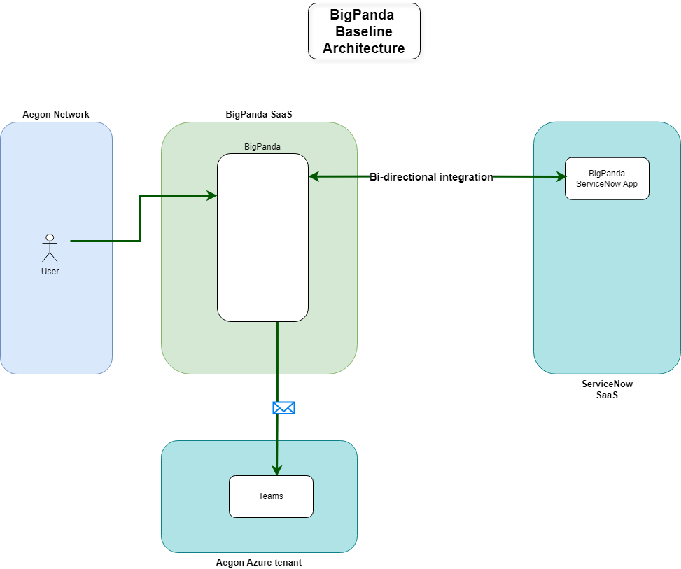

Target Architecture

Overview

The target solution integrates BigPanda AI seamlessly into the existing enterprise architecture by enabling the following services:

- Microsoft Teams Integration:
  - Microsoft Teams will integrate with BiggyAI to enable notifications, data retrieval, and direct interaction through the Teams chat interface. The Collaboration team will install the BiggyAI app in Aegon’s Azure tenant following provided guidelines. The Biggy Teams app is installed and restricted to authorized AD groups only.
  - The Microsoft Teams Integration for actions taken by Biggy (such as opening a bridge call, creation of major incident channel, etc) will be managed by an Active Directory Service Account. This Service Account will be maintained in CyberArk and manual password rotations will be performed every 90 days using the BiggyAI Administration console.
- OpenAI LLMs: BiggyAI leverages OpenAI language models hosted within BigPanda’s Azure tenant. Aegon does not have direct connectivity to these LLMs.
- ServiceNow Integration:
  - The ServiceNow integration from BiggyAI enables two capabilities.
    - The UDC (Unified Data Connector) connects to the ServiceNow environment, and indexes 1 year of historical Change, Incident, Problem data, as well as CMDB CI and Knowledge data. Additionally, it will check in a configurable cadence for any of the above that have been updated, and index that learned data as well.
    - The other capability is a live query for current state of any specific item of the above list. This originates from the same source as the UDC connection, but is used to ensure that the data provided is the current data, and not older indexed data (for example, when a customer asks about the Problem Tasks on a current Problem ticket, it retrieves the current state, and not historical learned data from the UDC connection).

  - Service Account: A local Service Account within ServiceNow is used for authentication. This authentication connects via the API Gateway, using OAuth 2.0. Password rotation for this account is the responsibility of the ServiceNow team.
  - Access via API Gateway: Real time data access in read only is required for the following ServiceNow tables. Access to ServiceNow will be implemented following approved hosting and browsing patterns by enabling secure and standardized access through Aegon’s API Gateway:
    - List of Tables that BiggyAI will be able to access
      - incident
      - change_request
      - problem
      - kb_knowledge
      - cmdb_ci
      - task_ci
      - change_task
      - problem_task
      - sys_user
      - u_kb_template_how_to_it
      - sys_user_group
    - List of API Endpoints that BiggyAI will be able to interact (with {table} in the below list is represented by the list of tables above)
      - GET /api/now/table/{table}
      - GET /api/now/table/{table}/{sys_id}
      - GET /api/now/on_call_rota/oncallgroups
      - GET /api/now/stats/{table}
      - GET /api/now/ui/meta/{table}
      - GET /api/now/doc/table/schema

  - Incident/Change/Problem Attachments: BiggyAI’s access will be restricted from reading or retrieving attachments on Incident Tickets, Change Tickets, Problem Tickets, or their associated tasks. This is a capability of BiggyAI, but we will not be leveraging it at the current time. Agreement has been made that this can be revisited with the Architecture Board at a later time if it is determined to be valuable to collect this data, and security controls will be reviewed if this discussion occurs.
  - SNOW Integration DR – The API Gateway connectivity into ServiceNow Model will be maintained to be used for connecting to ServiceNow Model should ServiceNow Production become unavailable in a disaster. This would be invoked by a request to the BigPanda vendor to point their ServiceNow UDC Integration to the ServiceNow Model office API Gateway connection.

- BiggyAI
  - AI Agent Assistant – Agentic AI Agent accessible through Microsoft Teams which enables users to ask BiggyAI for assistance troubleshooting, can operate and transcribe critical incident bridge calls, and perform advanced analytic requests based upon natural language requests.
  - Incident Prevention Dashboards – AI Analysis of incidents and changes to predict risk of an upcoming change, or identify problems by trending across incidents.
  - AIA – AI Incident Analysis – Function in BigPanda to use GenAI to summarize alert in human readable language.
  - Similar Incidents – Function in BigPanda to intelligently identify similar alerts that have occurred in the past within BigPanda.

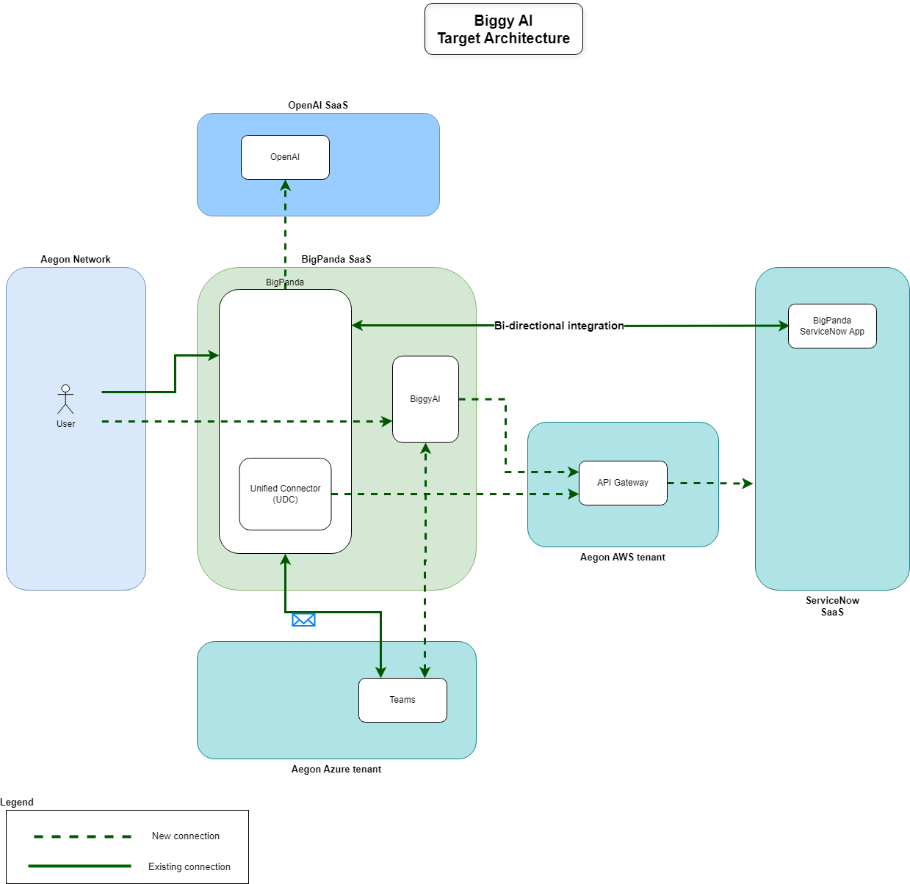

Technology Components & Architecture Impacts
List the technology components impacted by the change.
Technology Component Type | Technology Component Name | CMDB ID | Architecture Impact | Tech Lifecycle Strategy | Application Risk Rating
Business Application, Software, Hardware, Cloud Component | Application Name, Software Name, Hardware Name, Cloud Component Name | CMDB ID if in the CMDB  If not in the CMDB, indicate ‘New’  Prior to Project Solution - Final ARB, ‘New’ items must have a CMDB id to receive a passing score within the Architecture Alignment to Standards scorecard | Replace, Decom, Migrate, Re-use, Enhance, New | Buy, Hold, Sell  This is located in the Application IT Compliance Data in CMDB.  Search for the application an select the latest UPDATED date. The Application Lifecycle Strategy is on the right | Application Risk Rating is found by clicking on the link within the Application IT Compliance Data tab at the bottom of the application’s CMDB entry
SaaS | Teams | CI018550166 | Reuse | Buy | Low
Business Application | ServiceNow | CI002457504 | Reuse | Buy | High
COTS | API Gateway  (GTS SAAS-PAAS TO SAAS-PAAS API GATEWAY) | APM0004873 | Reuse | Buy | Critical
SaaS | BIGPANDA AI INCIDENT ASSISTANT (BiggyAI) | APM0006366 | New | Buy | Low

Gap Analysis

To reach the final target design, a proof of concept was executed in which an API Gateway in Aegon’s tenant was used as a proxy between BiggyAI, UDC, and the ServiceNow development environment. This setup enabled validation of the API Gateway pattern required by Aegon’s architectural standards and confirmed that the proposed approach met the expected integration requirements. In parallel, the integration with Microsoft Teams was verified by installing the BiggyAI module in Teams according to the vendor’s deployment instructions, ensuring that the required functionality operated correctly within the Teams environment.
All system accesses involved in this validation were provisioned using Entra ID groups, which ensured appropriate authorization and alignment with the organization’s access‑control model. The validation activities were performed across both the development and model environments, demonstrating that the intended design behaved as expected under these conditions.
Once the final Architecture Review Board (ARB) approval is obtained, the validated solution will proceed to deployment in the production environment

Components

Components or Patterns Used
This will include the logical high-level architecture diagram based on the previous contextual diagram and a list of components used in the solution (use links when possible).
GTS Component Architecture Standards (sharepoint.com)
GTS Reference Architectures (sharepoint.com)
GTS Architectural Patterns (sharepoint.com)

Component Architecture Diagram
Two integration patterns are implemented:
- Browsing Pattern: Used for both BigPanda web access and for queries to read data from ServiceNow transferred by the APIGateway
- Hosting Pattern: Used to receive queries sent to ServiceNow from Bigpanda’s UDC and BiggyAI
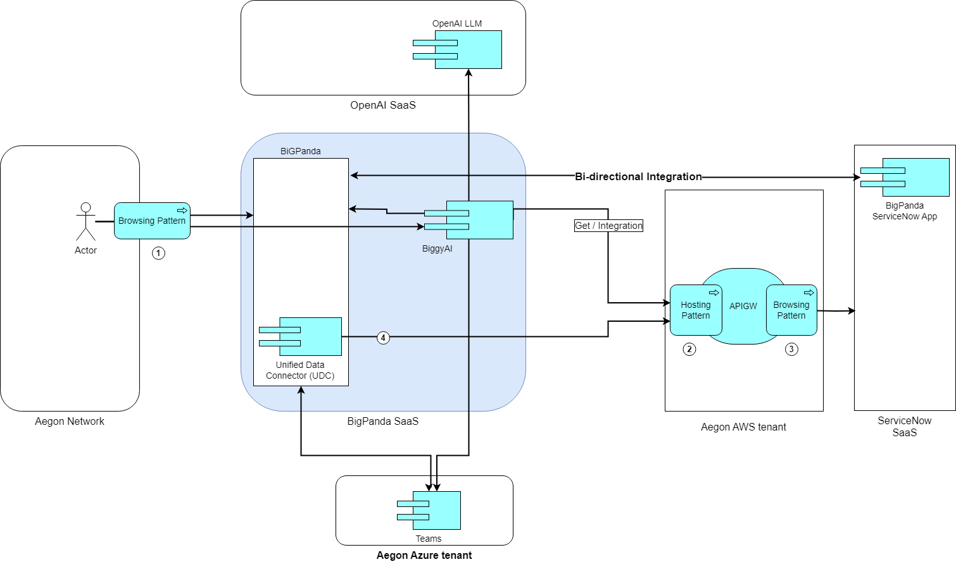

Components or Pattern Table
Components/Patterns Used |  | Link
1 | Browsing Pattern | GTS APIGW - Project Solution Design Document.docx
2 | Hosting Pattern | GTS APIGW - Project Solution Design Document.docx
3 | Browsing Pattern | GTS APIGW - Project Solution Design Document.docx

Data Flow
For production deployment, no non-standard implementations were identified. The solution leverages API Gateway as a proxy between BigPanda APIs originating from UDC and BiggyAI, and the ServiceNow portal. The solution uses OAuth 2.0 for secure authentication and is protected through IP whitelisting, ensuring compliance with security standards and streamlined operations.
Access to Teams in Aegon’s Azure Tenant will be granted via AD service account maintained in CyberArk and rotated every 90 days.

Data Flow Diagram
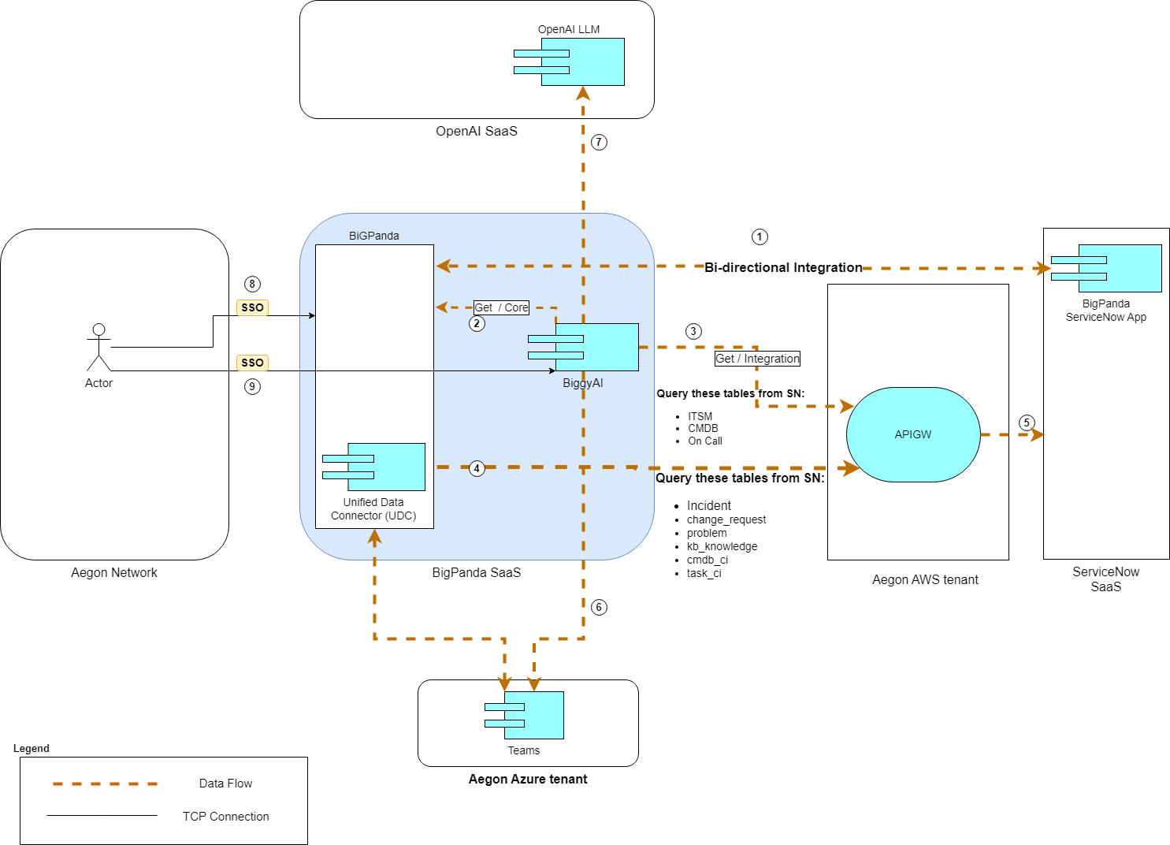

Data Flow Table

Data Flow Reference |  | Description
1 | BigPanda connection to ServiceNiw | Existing connection from BigPanda to ServiceNow (RITM0051519-ACBSD-2049- BigPanda Event Management Solution.docx).
2 | Biggy AI query to BigPanda | Internal connection to BigPanda network.
3 | BiggyAI query ServiceNow | BiggyAI queries to ServiceNow for data that has not been received yet after a user question.  Get API call using Oauth v2 through Aegon’s API gateway / SSL encryption / IP whitelisting is applied to allow BigPanda IPs
4 | BiggyAI query ServiceNow | BigPanda Unified Data Connector (UDC) trickle queries to ServiceNow  Get API call using Oauth v2 through Aegon’s API gateway / SSL encryption / IP whitelisting is applied to allow BigPanda IPs
5 | Call forward to ServiceNow | BiggyAI and UDC API calls forwarded to ServiceNow by Aegon’s API Gateway. Traffic encrypted with SSL.
6 | BiggyAI sends notifications to Teams channels.  BiggyAI Chatbot interaction with users. | BiggyAI sends notifications to dedicated channels over HTTPS. Permissions are granted using Resource-Specific Consent (RSC) permissions. Install BigPanda Biggy AI.  Access is granted with AD service account maintained in CyberArk and rotated each 90 days.  Users can interact with BiggyAI Teams Apps chatbot.
7 | OpenAI as LLM provider. | The underlying LLM used by BiggyAI is accessed through API calls to OpenAI. Currently, BiggyAI does not support the use of custom LLMs or allow selection among different OpenAI models.
8 | Users' interaction with BigPanda through the web portal. | Authentication using PingOne. Access granted using an appropriate role mapped to AD group.
9 | Users' interaction with BiggyAI through the web portal. | Authentication using Azure AD. Access granted using an appropriate role mapped to AD group.

Data Protection
BiggyAI is delivered as a Software-as-a-Service (SaaS) solution, with all operational responsibilities managed by the vendor. This includes ensuring High Availability and Disaster Recovery, as stipulated in the contractual agreement.
BiggyAI provides DLP protection by use of the Guardrails functionality. This redacts any configured PII from being returned, as well as prevents configured queries from being executed. Documentation on Guardrails function can be found here: https://docs.bigpanda.io/en/manage-biggy-configuration#guardrails

Observability
BigPanda is an approved SaaS solution within Aegon, with monitoring and alerting services managed by the vendor for BiggyAI. BigPanda plans to introduce support for Splunk for Audit Log collection, and once this functionality becomes available, Team Neptune will conduct testing in collaboration with the appropriate stakeholders to ensure successful implementation.
In the meantime, BiggyAI provides the possibility to export the audit log as CSV from the web portal as well as API query Connectivity to collect the logs from Splunk directly via API.
Usage, availability, and feedback reporting are available within the BiggyAI tool as reports. Additionally, there is an existing RSS feed from BigPanda which will alert us to any availability issues with the SaaS platform.

Authentication and Authorization
Access to the BigPanda portal (including Biggy) will be secured using Single Sign-On (SSO), with role-based permissions managed through Entra ID groups.
All API calls originating from the BigPanda (including Biggy) will be authenticated using OAuth 2.0 and further protected by IP whitelisting, with all traffic routed via API Gateway hosted in Aegon’s AWS tenant.
As a result, the production rollout does not require any non-standard integration patterns.
Entitlement reviews will be conducted 1/year. For teams that have BiggyAI Agent access, entitlement reviews will be conducted with the team managers. For individuals have BiggyAI Agent access individually, entitlement reviews will be conducted on an individual basis.

Security Boundaries

The following security boundaries have been considered for BigPanda and Biggy usage in production.
- Hosting pattern: The POC validated its use for secure connectivity to BigPanda portal.
- API Gateway: Tested between BigPanda/BiggyAI and ServiceNow sandbox environment to enforce security controls and maintain internal audit logging.
- IP whitelisting: In addition to the hosting pattern, we explicitly enabled IP whitelisting for API calls originating from BigPanda to the API Gateway.

Security Boundaries Diagram

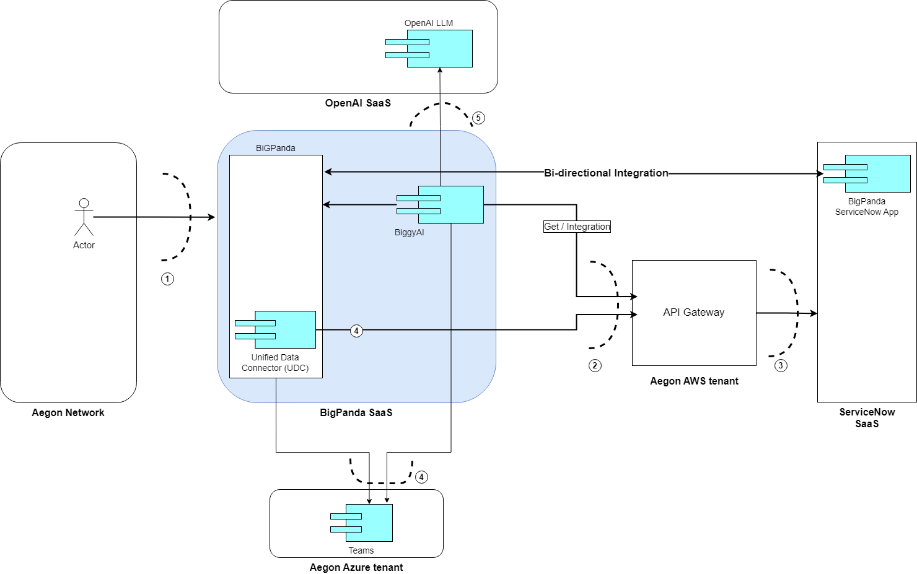

Security Boundaries Table

Security Boundary Reference | Existing Pattern? | Description
1 | Browsing Pattern | Corporate Firewall.
2 | Hosting Pattern | Corporate Firewall + LB.  APIs calls accepted only from whitelisted BigPanda’s IPs.
3 | Browsing Pattern | Corporate Firewall.
4 | N/A | Access to Teams in Aegon’s Azure tenant, authentication with EntraID
5 | N/A | BiggyAI access to LLMs hosted in BigPanda Azure tenant. All connectivity and management of this integration are handled exclusively by BigPanda.

Data Solution

Data Classification

Data Confidentiality Classification |  |  |  | Data Legal and Regulatory Classification
☐ | Strictly Confidential |  | ☐ |  | Financial Information
☐ | Confidential |  | ☒ |  | Personal Identifiable Information
☒ | Internal |  | ☐ |  | Protected Health Information
☐ | Public |  | ☐ |  | Payment Card Information
☐ | No Data Shared |  | ☐ |  | No Personal Data Shared

Privacy Impact Assessment (PIA)
Work with the Data Officer to assess the potential impact on the privacy of individuals. Include the PIA reference
Text

Data Encryption and Residency

All data exchanged between Aegon’s users, BiggyAI, and BigPanda is secured using HTTPS with TLS 1.2 encryption. This same level of encryption is applied to all data in transit between the BigPanda network and the integrated third-party SaaS services, including ServiceNow, Microsoft Teams (hosted on Azure Cloud), and the Open LLM environment within Azure.

Data Retention

BigPanda does not delete client data by default. It is not desirable to delete historical data within the Vector Database to better assist in troubleshooting with infrequent issues. It can be deleted on demand if required.

Data Residency

BiggyAI instance used by Aegon will be deployed in the United States, the same region where the main BigPanda instance is deployed.

GenAI
GenAI Inventory #GTS030

Service Model and Shared Responsability
In this solution, security and operational responsibilities are distributed between Aegon and BigPanda according to the shared responsibility model. BigPanda, as the SaaS provider, is responsible for securing its platform, including infrastructure, application-level security, and compliance with industry standards. This covers aspects such as vulnerability management, patching, and ensuring encryption for data in transit and at rest within its environment.
Aegon, as the consumer of the SaaS service, is responsible for securing its own integrations and usage of the platform. This includes managing access controls, enforcing internal security policies, configuring API gateways, implementing IP whitelisting, and ensuring that data exchanged with BigPanda aligns with Aegon’s compliance requirements. Aegon also retains responsibility for monitoring and auditing activities within its environment and for any third-party integrations connected to BigPanda.
Ultimately, BigPanda ensures the security of the SaaS platform itself, while Aegon ensures secure consumption and integration of that platform within its enterprise ecosystem.

RACI Chart
Key Activity, Milestone, or Decision | Global Enterprise Architecture | Global Infrastructure Platform Engineering | ServiceNow Platform Team | End Users | Global Information Security Services
Collect Audit Logs from BiggyAI |  | C/I |  |  | R/A
Define Security Requirements | R | C/I |  |  | R/A
Create Architecture Documentation | R/A | C/I |  |  | C/I
Arrange ARB approval | R/A | C/I |  |  | C/I
Define Integrations and Tool Usage | C/I | R/A |  | C/I | C/I
Rotate Credentials for Biggy SNOW Service Account |  | C/I | R/A |  | I
Rotate Credentials for Biggy Teams Service Account |  | R/A |  |  | I
Arrange required budget for tooling licences | C/I | R/A |  | C/I | C/I
Conduct Entitlement Reviews for BiggyAI Agent Access |  | R/A |  | C/I | I
Arrange required budget for resources maintaining tools | C/I | R/A |  | C/I | C/I
Implement and maintain tools | C/I | R/A |  | C/I | C/I
Implement required integrations | C/I | R/A |  | C/I | C/I
Support Tool Availability |  | R/A |  | C/I
Review and Improve Capabilities | C/I | R/A |  | C/I | C/I
Conduct license management | C/I | R/A |  | C/I | C/I
Conduct user training |  | R/A |  | C/I
Establish and Maintain Community of Practice | C/I | R/A |  | C/I | C/I

Implementation Approach

Proposed level of coordination
The production integration of BiggyAI with ServiceNow will progress through the following environments to ensure proper validation and compliance:
- Sandbox
- SNOW Development (OW region)
- SNOW Model Office
- SNOW Production

Dependencies
The main dependency for BiggyAI deployment in production are:
- Setting Azure EntraID for authentication
- Setting Aegon’s API Gateway as proxy between BiggyAI, BigPanda UDC and ServiceNow

Waivers and/or Exceptions
No exception or waivers are required for this Solution Design.

Licensing
BiggyAI comes in two licenses.
Enterprise license with these features:
- Incident Detection and Response – Part of existing actioned events license for BigPanda
- Incident Prevention Module – Single enterprise license usable by all employees.

User license for BiggyAI for chat functions:
- Incident Assistant Teams Agent – Licensed per user
  - 25 users in year 1
  - 100 users in year 2-5

Exit Strategy
N/A

Appendix A: Architecture Review Board Scorecard
<link to scorecard>

Appendix B: Related Documents
Links and other pertinent references

Appendix C: Glossary of Terms and Acronyms

